Upcoming Events

Protecting ourselves, our coast and our culture.

What has been done, and what remains?

This week LA SAFE and June 27th the Terrebonne Parish Coastal Day:

1. **LA SAFE community meetings**

Following up on earlier parish-wide meetings, LA SAFE staff is holding meetings at three locations around the Parish this week.  The goal is that in these open discussions residents will identify and prioritize programs that will help facilitate adaptation and support community needs.  The state will take the information and develop a plan to capture parish priorities and projects based on environmental risk factors, economic sense, and social/cultural benefits.

$40M HUD Grant to Louisiana Office of Community Development (OCD) for parishes with unmet needs from Hurricane Isaac in 2012; additional support from Foundation for Louisiana; continued efforts to leverage and expand resources.

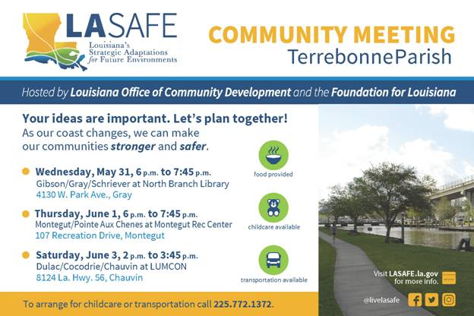

**Terrebonne Parish Coastal Day**

**June 27th,** Terrebonne Parish will be providing an interactive showcase for the community to learn about Terrebonne Parish Coastal protections in place and planned for the future.  The event is free and open to the public.  Food, displays, and panel discussions regarding levees, floodgates, elevations, and marsh/barrier island restoration. Come.  Learn. Share.

